|  |  |
| --- | --- |
| **PROJECT NAME** | **SMARTFORMER IOT ENABLED SMART FORMING** |
| TEAM ID | **BNT2022TMID47605** |
| STUDENT NAME | **MS. N. ANNA POORANI** |
| MARKS | **2 MARKS** |

**ASSIGNMENT 2**

**PYTHON PROGRAMING**

**QUESTION:**

Build a python code, assume u get temperature and humidity values (generated with random function

**SOLUTION:**

**PROGRAM:**

**import random**

**from time import sleep**

**while True:**

**temperature=round(random.uniform(10, 50),2)**

**humidity=round(random.uniform(10, 100),2)**

**print("\nTemperature =", temperature,"degreecelsius")**

**print("Humidity = ",humidity,"%")**

**if(temperature>32):**

**print("STATE : ALARM ON")**

**else:**

**print("STATE : ALARM OFF")**

**sleep(5)**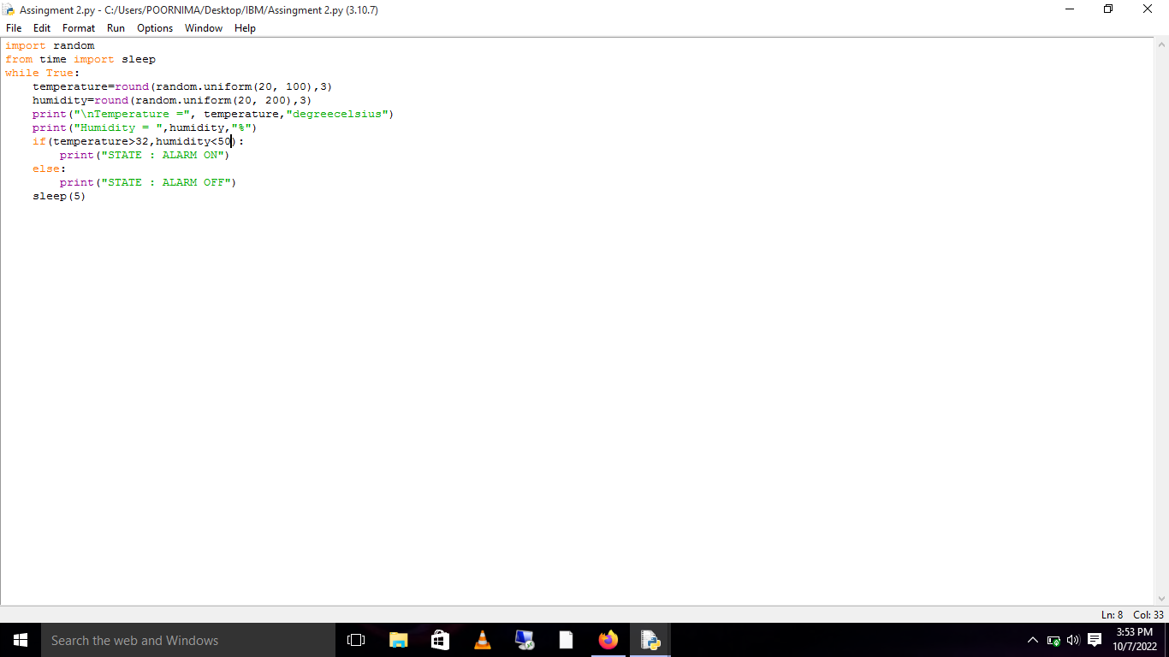

**OUTPUT**

